10 Ideas for MLOps Projects

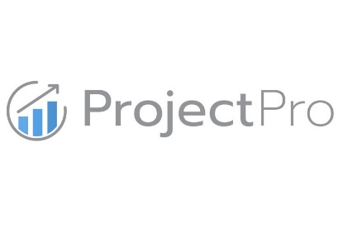

**Anish Mahapatra**

Contents

List of Figures 3

Introduction 4

Designing a MLOps Solution 5

# List of Figures

Fig 1: The complete MLOps process 4

Fig 2: The MLOps Stack Template (Source) 5

# Introduction

Data Science is losing it’s title of the “Sexiest job of the 21st Century”.

*87% of Data Science Projects never make it to production -* [*VentureBeat*](https://venturebeat.com/2019/07/19/why-do-87-of-data-science-projects-never-make-it-into-production/)

Jobs over the next decade are going to leverage the fundamentals of Data Science and build on top of that for production. Data Science has flourished over the decade on the promise that companies will make money using analytics. Data Science can make money only when AI/ML projects are in production. **MLOps roles will replace Data Science jobs** in the next decade. MLOps seems to be the new buzz word floating around in the Data Science world and it is critical to understand what it really means.

MLOps aims to provide an end-to-end machine learning development process to design, build and manage reproducible, testable and evolvable ML-powered software. The cloud strategy of organizations plays a key role when it comes to production as custom solutions have to be built depending on the needs of the company. The complexity associated with MLOps is one of the main reasons we have not seen a one-size-fits-all approach. In this article, we will go through a few end-to-end projects that will explain how MLOps can be leveraged to make a Data Science project production ready.

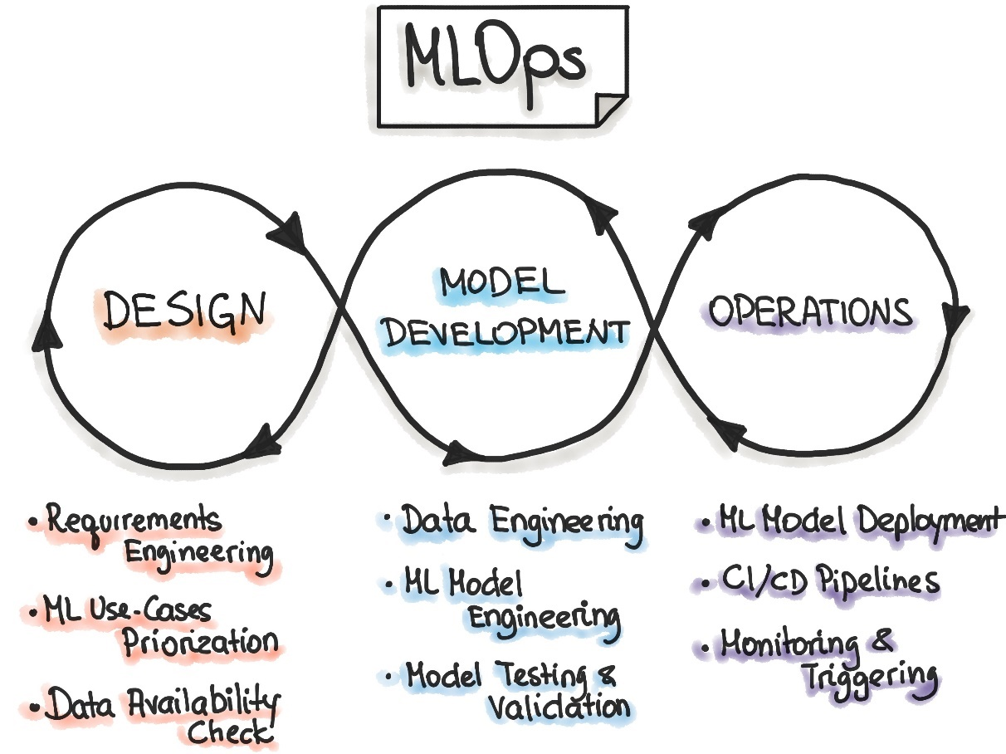

Fig 1: The complete MLOps process

# Designing a MLOps Solution

At the moment, the MLOps landscape is frequently evolving. The number of tools available for a single task are many – this leads to multiple options, which is alwas a good thing, but, it also means that we have to decide what will work best in out use-case. A good way to make projects more tangible is to focus on the stack. This can be complicated in deifferent settings and we have to make MLOps real for it to work. Where DevOps has a CI/CD approach to software solutioning, MLOps has a Continuous Integration (CI), Continuous Delivery (CD), Continuous Training (CT), Continuous Monitoring (CM) approach.

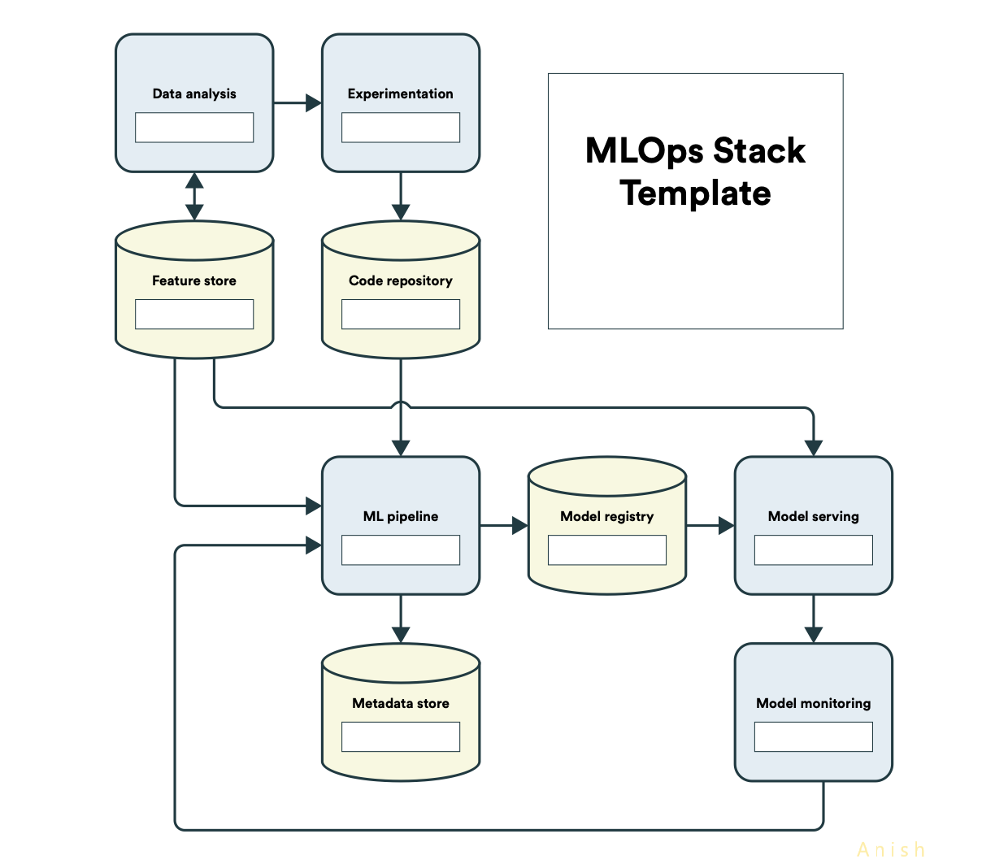

Fig 2: The MLOps Stack Template ([Source](https://ml-ops.org/content/state-of-mlops))

The MLOps Stack template is a good start on how we can think about MLOps solution design when implementing at scale for various organizations. The components are as follows:

* **Data Analysis**: The analysis component of the MLOps flow can be done with the help of various tools
* **Experimentation**: Output-focused experimentation along with domain knowledge can help select the relevant toolset
* **Feature Store**: Feature stores are used to store variations on the feature set leveraged for machine learning models that multiple teams can access
* **Code Repository**: The data and code repository has to be selected such that it fits into the MLOps stack being used, especially if it is on the cloud
* **ML Pipeline**: Similar to data pipeline, ML pipelines help carry the state of the machine learning project from data to ML output
* **Metadata Store**: Metadata for larger and evolving datasets can be housed in metadata stores
* **Model Registry**: Logging models are done in the model registry, this setup helps reflect back on multiple iterations
* **Model Serving**: Model serving is critical to production, it is the interface of machine learning with the real world
* **Model Monitoring**: Monitoring the model parameters in the real-world post production is critical to adjust various components to ensure that the feedback loop is met and the expected output is delivered in production consistently

Now that we have got a clear understanding on the components required to design for solution, we are on track to look at project ideas for MLOps. One nuance of the current state of MLOps is that it is in the very nascent stages of development – all major cloud platforms and various open-source applications are all trying to solve for production-ready machine learning. So, in the project ideas below, we will look at the project ideas where we can implement components of MLOps to make data science projects more MLOps ready.

# 1 Perfect project Structure – Cookiecutter & readme.so

From the MLOps process flow, if there is one thing you can incorporate in your projects right now, it is improving your Data Science Structure. To automate this, there is great package called [cookiecutter](https://drivendata.github.io/cookiecutter-data-science/#cookiecutter-data-science) that helps build the structure of real-world machine learning implementations. The goal of cookiecutter is to make it easier to start, structure and share an analysis.

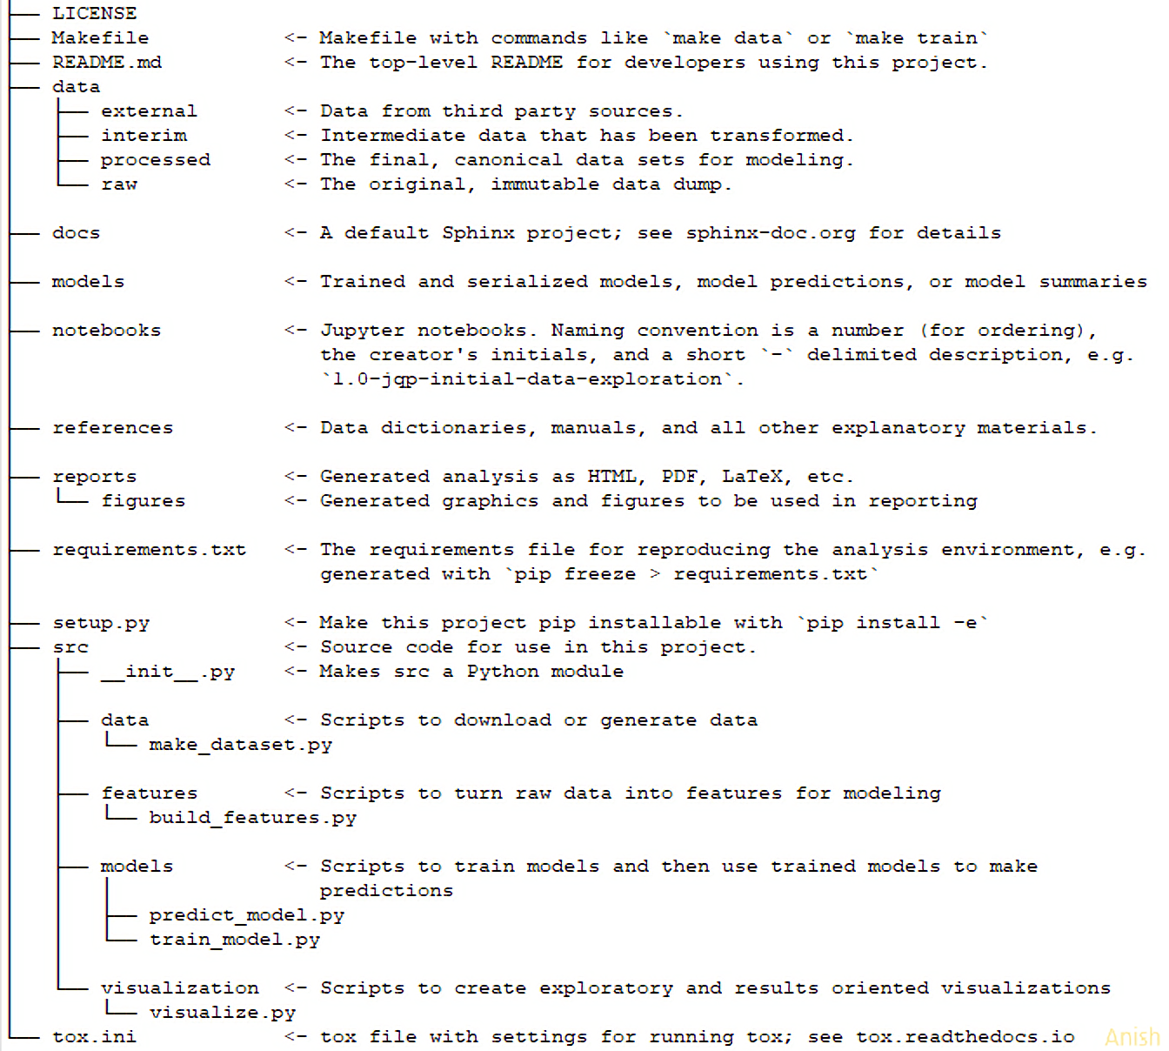

Fig 3: Cookiecutter Folder Structure ([Source](https://drivendata.github.io/cookiecutter-data-science/#cookiecutter-data-science))

Another major component where Data Scientists lack is in providing information and documentation in their projects. So, when returning to your own project after a period of time, a lot of information is missed out. Markdown files, particularly readme.md files can be compliated to create, especially if you want to do them well. So, use an editor from readme.so to help you in real time.

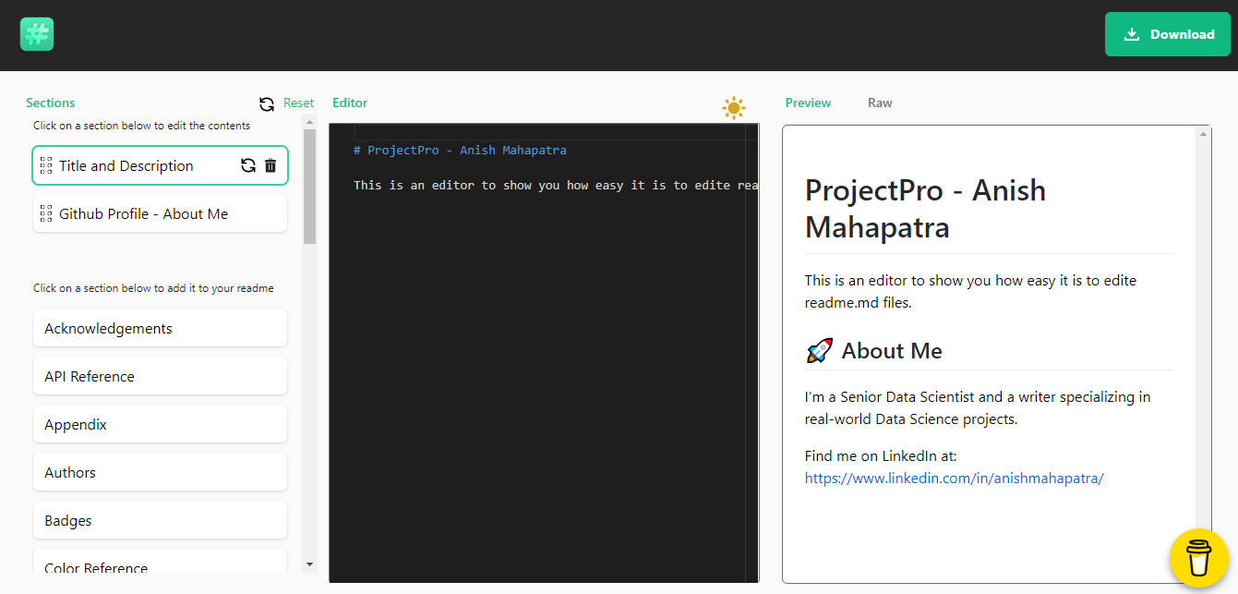

Fig 4: GUI for Markdown Editor ([readme.so](https://readme.so/editor))

This is bound to impress interviewers and demarcate you as an expert in most interviews as a lot of teams face issues when it comes to the standardization of machine learning in production. Adopting these in your personal GitHub projects wll definitely make you stand out as an expert in MLOps.

## Project Idea

Take any project you have done and implement it with a high-quality readme.md file leveraging [readme.so](https://readme.so/editor) and data science project structure using [cookiecutter](https://github.com/drivendata/cookiecutter-data-science). Let’s say you are a beginner and want to get started, head over to the [Kaggle Titanic EDA to ML Challenge](https://www.kaggle.com/dejavu23/titanic-eda-to-ml-beginner) and focus on building the project out using cookiecutter and high-quality documentation as expected from a production machine learning perspective. Please remember, in production, the actual process of Data Science does not change, rather the way we approach solution design evolves.

# 2 Speed Exploratory Data Analysis to minutes – Pandas Profiling, SweetViz

Exploratory Data Analysis (EDA) is something beginners in Data Science fear. Especially when multiple teams are working towards demystifying the data to ensure that complete understanding of the data is done, there is bound to be some gaps between the teams and the business. Another gap that is prevelant in the real-world is the presentation of EDA to business stakeholders. The process of retrieveing images/analysis from Jupyter Notebooks to a presentation can be a tedious process prone to errors. To counter this, there are ways to effective speed up the process of EDA.

The packages that can be used to generate reports that can be downloaded as html files to showcase end to end exploratory analysis are as follows:

* [Pandas Profiling](https://github.com/pandas-profiling/pandas-profiling): Helps with quick analysis of the data with inclusions such as type inference, unique values, missing values, quantile statistics, descriptive statistics, histogram, correlations, text analysis etc. Just one line of code will enable you to quickly perform initial EDA in a visually appealing and shareable format. This is one of the best packages you can try to impress quickly.

pandasreport = ProfileReport(df, title=”New Report Sample”)

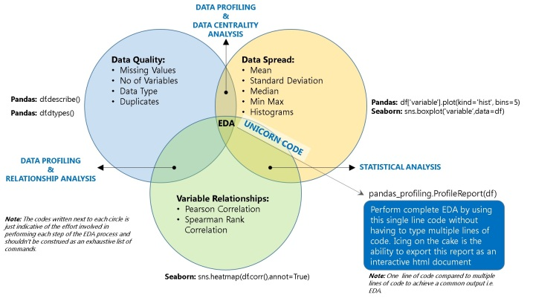

Fig 5: Pandas Profiling ([Source](https://dzone.com/articles/pandas-one-line-magical-code-for-eda-pandas-profil))

In the Project idea section, we will talk about a good dataset you can use to try Pandas Profiling out.

* [SweetViz](https://pypi.org/project/sweetviz/): SweetViz is a fantastic package to perform exploratory data analysis, designed by a graphic designer. These packages work inline on Jupyter Notebook as well as online editors such as Google Colab. SweetViz offers in-depth EDA that goes a step further from Pandas profiling by offering target analysis, feature analysis, comparison and correlation analysis.  
    
  import sweetviz as sv  
    
  sweetVizReport = sv.analyze (sampleDataFrame)  
  sweetVizReport.show_html()

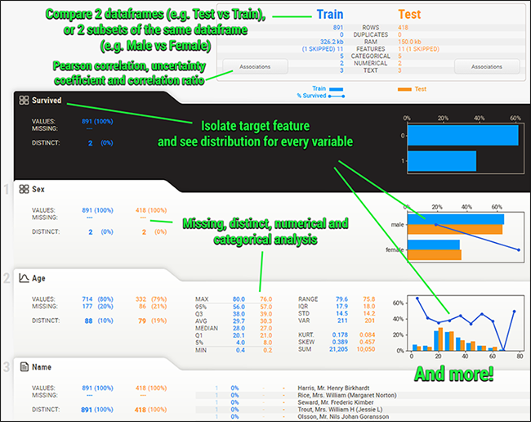

Fig 6: SweetViz Features ([Source](https://pypi.org/project/sweetviz/))

## Project Idea

A good dataset to understand visual bias is the [Zomato Restaurants dataset](https://www.kaggle.com/shrutimehta/zomato-restaurants-data). It is a decent dataset to query with multiple nuances that can be analyzed. Focus on performing a preliminary analysis of the data using python followed by leveraging pandas profiling and sweetviz. The source code for inspiration can be found [here](https://github.com/anishmahapatra/Zomato-Data-Visualization). It can either be performed on Jupyter Notebook or on Google Colab (inline as well as spearate files that can be generated).

# 3 Track Data Science Projects with CI, CD, CT, CM – Data Version Control (DVC)

Data Science Projects in production need multiple components to work seamlessly to generate reliable results. [DVC](https://dvc.org/) is built to make models shareable and reproducible. Where GitHub only focuses on the code, consider DVC as the big brother for Data Science. It is designed to handle large files, data sets, machine learning models, metrics as well as code. The three main components that differentiate the offering of DVC are as follows:

* **ML project version control**: Works with Amazon Web Services (AWS), Microsoft Azure, Google Cloud Platform, SFTP, HDFS, HTTP, netowork attached disks or even locally.
* **ML experiment management**: Git branches along with data and metrics tracking to enable Continuous Training (CT) and Continuous Monitoring (CM), this enables a cleaner structure
* **Deployment & Collaboration**: Leverage the classic push/pull along with data version control to collaborate and even orchestrate as a team.

This helps save and reproduce experiemnts, version control models and data and aids in establishing workflow for deployment & collaboration.

## Project Idea

Build out a machine learning project and perform version control with dvc. Build a dependency graph to operationalize pipelines and showcase hoe dvc can be leverage to reproduce AI/ML prodcution models at scale. The main components that can be work upon in this project are Data and Model Version Control, Data and Model access, Data Pipeline (DAGs), Metrics, Parameters and Plots, and finally experiments. Leverage the [Kaggle Telco Customer Churn Dataset](https://www.kaggle.com/blastchar/telco-customer-churn) to perform EDA, data cleaning and modelling and invoke the same using DVC. You can take code inspiration from this repoitory [here](https://github.com/anishmahapatra/Classification-Telecom-Customer-Churn).

# 4 Explainable AI / XAI – SHAP, LIME, SHAPASH

An end-to-end project where the output of the model and the reasoning behind each of the decisions of the model can be really helpful in the real world to explain to the business stakeholders. Where Feature Selection tackles the issue of the selection of important columns for modelling, Explainable AI puts forth focus on what are the micro-decisions that lead to the final macro decision

# 5 Deploy projects in minutes – Docker, FastAPI

A

# 6 End to End Machine Learning – mlflow, Seldon.ai

A

# 7 Model Registry – MLStore, FeatureStore

A

# 8 Big Data using Python, instead of PySpark – DASK

A

# 9 Build a Chatbot and deploy it (open-source)

A

# 10 FaaS framework implementation – Apache OpenWhisk, OpenFaas

A